In summary, big data analytics tools are a kind of newly developed tools which have become essential for crafting systematical strategies in many areas. Such tools not only have capabilities of facilitating the uncovering of hidden correlations which could not be detected efficiently in the past, but could enable personalized experiences by powering recommendation and decision systems across industries. Also, their application extends to many areas of everyday life, including weather forecasting and shopping recommendation systems. Although some are concerned about its widespread adoption and equitable application, scientists have been addressing such problems efficiently. In a world which is full of all kinds of data, big data analytics tools could make a big difference to everyone’s life.

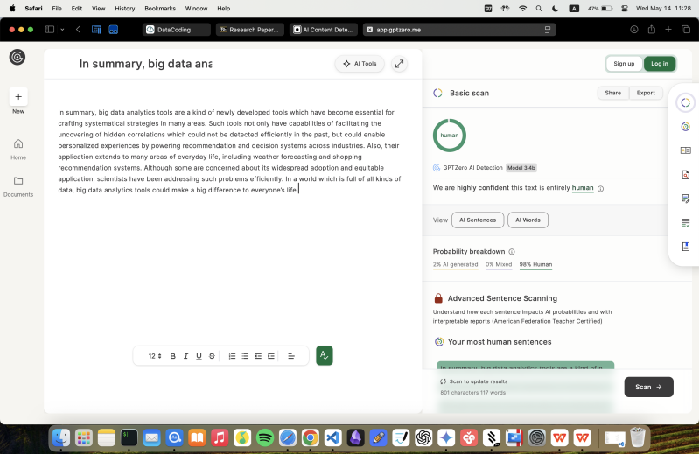

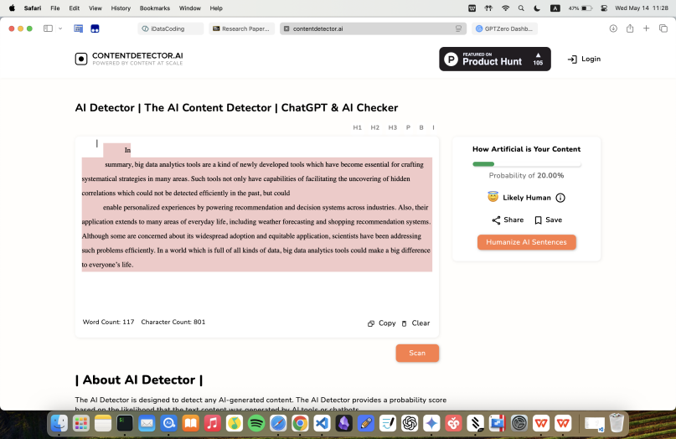

**References**

Duarte, F. (2025, April 24). Amount of data created daily (2025). *Exploding Topics*. <https://explodingtopics.com/blog/data-generated-per-day>

Estape, E. A., Mays, M. H., & Sternke, E. A. (2016). Translation in Data Mining to Advance Personalized Medicine for Health Equity. *Intelligent Information Management*, 8(1), 9-16. <https://doi.org/10.4236/iim.2016.81002>

Luo, Y. (2024). Optimization of product marketing and management path of cross-border e-commerce enterprises relying on big data technology. *Applied Mathematics and Nonlinear Sciences*, 9(1), 1-19. <https://doi.org/10.2478/amns.2024.1.00001>

Precision medicine needs an equity agenda. (2021). *Nature Medicine*, 27(5), 737. <https://doi.org/10.1038/s41591-021-01373-y>

Ren, S. (2022). Optimization of enterprise financial management and Decision-Making systems based on big data. *Journal of Mathematics*, 2022(1). <https://doi.org/10.1155/2022/1708506>

Thimmanna, Sharma, A. V. N. S., Naik, M. S., Radhakrishnan, S., & Sharma, A. (2024). Personalized Learning Paths: Adapting Education with AI-Driven Curriculum. *European Economic Letters*, 14(1). <https://doi.org/10.52783/eel.v14i1.993>

Ward, M. M. (2012). Personalized therapeutics: a potential threat to health equity. *Journal of General Internal Medicine*, 27(7), 868–870. <https://doi.org/10.1007/s11606-012-2002-z>